Project Title: QUIZHUBB

- JS Validation: (minimum 5(any 5 logic) screenshot of JS Validation)

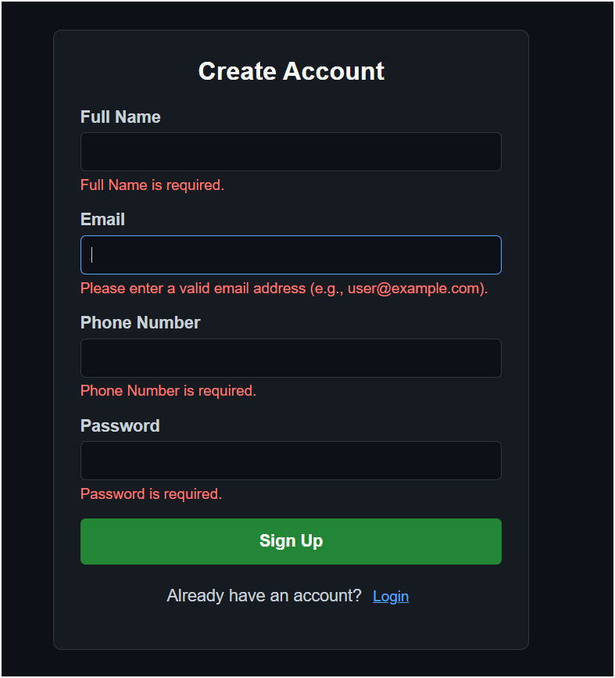
Fig 1.1 JS Validation: All fields are required

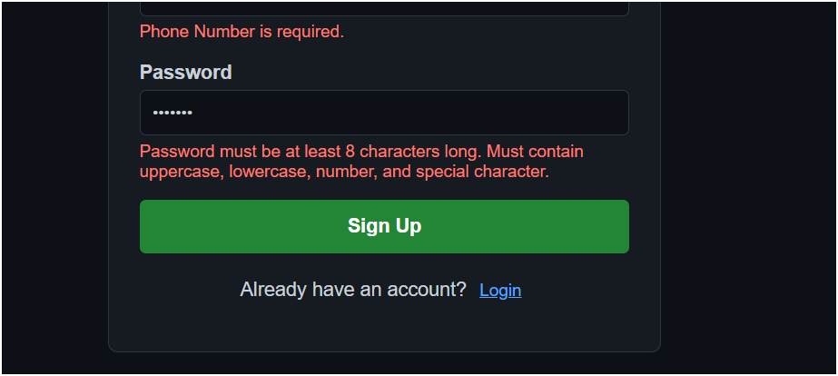
Fig 1.2 JS Validation: Password Length


Fig 1.3 JS Validation: Email Pattern

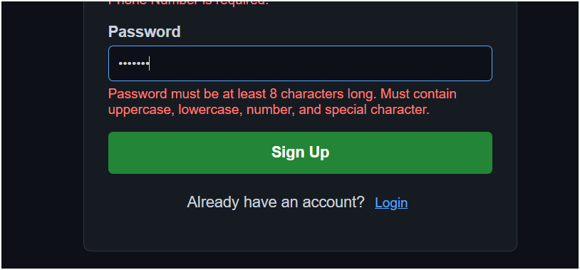
Fig 1.4 JS Validation: Password Pattern

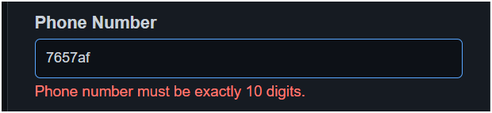
Fig 1.5 JS Validation: Phone number pattern

